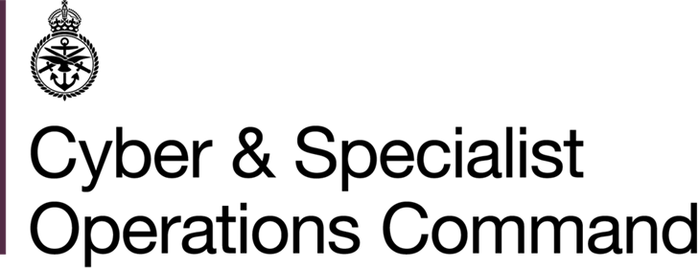 | GEO LEC HR  Bld 139 Normandy Barracks  Sennelager  BFPO 16
 | Telephone MOD:  Teams  E-mail: | +49 (0)5254 982 2677  +44 303 369 2106  CSOCIGDN-GEO-LECHR-SEN@mod.gov.uk
02 June 2026

Reference: GC/Dep/2026/13

EMPLOYMENT VACANCY (DEPENDANT)

1. This post is available to candidates who in the first instance meet the criteria of dependant as presented in Art I.1.c of the NATO SOFA. The employing model type, Art I.1.b, presents further restrictions on eligibility as any applicant cannot be stateless persons, nor nationals of any State which is not a party to the North Atlantic Treaty or the NATO Partnership for Peace, nor national of, nor ordinarily resident in Germany.

2. Applications are invited from suitably qualified and experienced staff for the post located in the agency Germany Central Paderborn / Sennelager. It would be appreciated if this circular could be disseminated as widely as possible so that interested applicants may apply.

_______

Unit Post/Grade/Hours Closing date
for applications
_____________________________________________________________________________

Germany Enabling Personnel Statistical Information 17.07.2026 Office (GEO) Administrator
C4 30 hpw

Start date: asap, vetting dependent
_____________________________________________________________________________

3. Closure date for the submission of applications is shown above. Further information including a job description may be obtained from GEO LEC HR recruitment staff or by accessing our website

http://bfgnet.de/employment

4. The following qualifications / experience are essential:

- Competent knowledge of the English language (both verbal and written).
- Recognised qualification demonstrating proven knowledge and experience in IT systems and Office 365.
- Work independently, under pressure and against tight deadlines and demonstrate initiative when handling problems.
- Required to make decisions in connections with post responsibilities.
- Ability to communicate accurately and clearly, in person or by e-mail.
- Cat B driving licence.
5. The following qualifications / experience are desirable:

  - Clerical or administration background.
  - Background / experience in statistical data management, interrogation and report generation.
  - An understanding of both the Data Protection Act (DPA) and the NATO Status of Forces Agreement (SOFA).
  - Knowledge and experience on SharePoint.

6. Applications must be in writing, using the GEO LEC HR Dependant Employment Application Form only. E-mailed application forms are acceptable and should be sent to:

CSOCIGDN-GEO-LECHR-SEN@mod.gov.uk

and must reach GEO LEC HR by the closing date shown.

7. These are reserved posts. In order to comply with current recruiting and baseline security check instructions, applicants who have been previously employed outside of Germany will be required to confirm their employment history covering past years. Background checks will need to have been fully completed before applications can be processed. All checks will be treated in accordance with the Data Protection Act.

8. Please also be aware that the working hours listed for the vacancy advertised are not fixed and should not stop you from applying. Flexible working patterns are encouraged and, where the job will allow, we may be able to change the hours to suit your personal circumstances. When applying, please state your availability in Part A4 of the job application form.

9. GEO LEC HR will filter these applications if the number of applicants makes it necessary to compile a shortlist.

Germany Enabling Office is fully committed to providing a working environment that is free from abuse and harm. We actively promote a free and safe culture, promoting the welfare of vulnerable groups, including children, within all of our work environments by clearly identifying and communicating the roles and responsibilities within the organisation and engaging with vulnerable groups including children, in policy and practice development.
Furthermore, we proactively encourage feedback and apply a zero tolerance to any form of abuse and harm.

