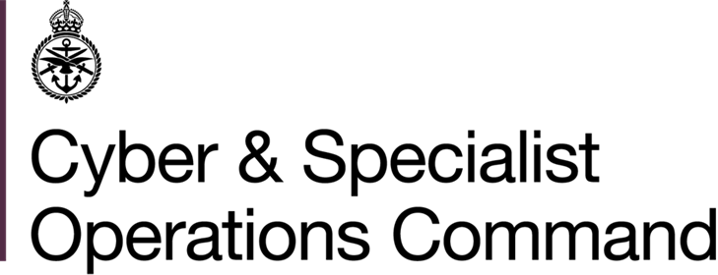 | GEO LEC HR  Bld 139 Normandy Barracks  Sennelager  BFPO 16
 | Telephone MOD:  Teams  E-mail: | +49 (0)5254 982 2933  +44 3001 1512 346  GSO-GEO-LECHR-Sen-GpMailbox@mod.gov.uk
15 May 2026

Reference: GC/DEP/2026/12

EMPLOYMENT VACANCY (DEPENDANT)

1. This post is available to candidates who in the first instance meet the criteria of dependant as presented in Art I.1.c of the NATO SOFA. The employing model type, Art I.1.b presents further restrictions on eligibility as any applicant cannot be stateless persons, nor nationals of any State which is not a party to the North Atlantic Treaty or the NATO Partnership for Peace, nor national of, nor ordinarily resident in Germany.

2. Applications are invited from suitably qualified and experienced staff for the post located in the agency Germany Central Paderborn / Sennelager. It would be appreciated if this circular could be displayed on unit civil labour notice boards so that interested applicants may apply.
_______

Unit Post/Grade/Hours Closing date
for applications
______________________________________________________________________________

Defence Children Class Learning Support 02.06.2026 Services (DCS) Assistant

Attenborough School LSA 2/2Q 28.75 hpw – term-time only

Start date: asap
______________________________________________________________________________

3. Closure date for the submission of applications is shown above. Further information including a job description may be obtained from GEO LEC HR recruitment staff or by accessing our website

http://bfgnet.de/employment

4. The following qualifications / experience are essential:

- Level 2 literacy and numeracy.
- Sufficient knowledge of the English language (verbal and written).
- Knowledge and understanding of the role of Teaching Assistant.
- Ability to use initiative.
- Ability to work well as a team member.
- Good communication and interpersonal skills.
- Ability to motivate pupils.
- Ability to form and maintain appropriate relationships and personal boundaries with children.
- Emotional resilience in working with challenging behaviours and attitudes to use of authority and maintaining discipline.
- Motivation to work with children.

The following qualifications / experience are desirable:

- Further study or extended training relevant to the post applied for, e.g. NVQ etc.
- Experience of working with children in an educational setting.
- Knowledge and understanding of the KS1/2 curriculum.

5. Applications must be in writing, using the GEO LEC HR Dependant Employment Application Form only. E-mailed application forms are acceptable and should be sent to:

GSO-GEO-LECHR-Sen-GpMailbox@mod.gov.uk

and must reach GEO LEC HR by the closing date shown.

6. These are reserved posts. In order to comply with current recruiting and baseline security check instructions, applicants who have been previously employed outside of Germany will be required to confirm their employment history covering past years. Background checks will need to have been fully completed before applications can be processed. All checks will be treated in accordance with the Data Protection Act. Safer recruitment practice will be followed, and pre-employment background checks will be undertaken before any appointment is confirmed. The post is subject to an enhanced DBS check, prohibitions from teaching check, and if the applicant has lived or worked abroad overseas checks from all relevant locations.
7. GEO LEC HR will sift these applications if the number of applicants makes it necessary to compile a shortlist.

Germany Enabling Office is fully committed to providing a working environment that is free from abuse and harm. We actively promote a free and safe culture, promoting the welfare of vulnerable groups, including children, within all of our work environments by clearly identifying and communicating the roles and responsibilities within the organisation and engaging with vulnerable groups including children, in policy and practice development.
Furthermore, we proactively encourage feedback and apply a zero tolerance to any form of abuse and harm.

