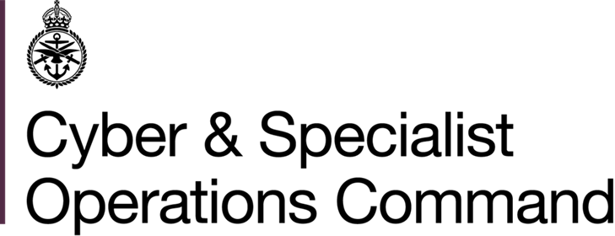 | GEO LEC HR  Bld 139 Normandy Barracks  Sennelager  BFPO 16
 | Telephone MOD:  Teams  E-mail: | +49 (0)5254 982 2677  +44 303 369 2106  GSO-GEO-LECHR-Sen-GpMailbox@mod.gov.uk
23 January 2026

Reference: GC/Dep/2026/02

EMPLOYMENT VACANCY (DEPENDANT)

1. This post is available to candidates who in the first instance meet the criteria of dependant as presented in Art I.1.c of the NATO SOFA. The employing model type, Art I.1.b, presents further restrictions on eligibility, as any applicant cannot be stateless persons, nor nationals of any State which is not a party to the North Atlantic Treaty or the NATO Partnership for Peace, nor national of, nor ordinarily resident in Germany.

2. Applications are invited from suitably qualified and experienced staff for the post located in the agency Germany Central Paderborn / Sennelager. It would be appreciated if this circular could be disseminated as widely as possible so that interested applicants may apply.

_______

Unit Post/Grade/Hours Closing date
for applications
______________________________________________________________________________

Defence Children Teacher Cover - 16.02.2026

Services (DCS) Supervisor - qualified
Attenborough School

€27.44 per hour for qualified teachers

Start date: asap, vetting dependent
______________________________________________________________________________

3. Closure date for the submission of applications is shown above. Further information including a job description may be obtained from GEO LEC HR recruitment staff or by accessing our website

http://bfgnet.de/employment

4. The following qualifications / experience are essential:

- Qualified teachers must hold:

- Qualified Teacher Status (QTS) or Qualified Teacher Learning Skills Status (QTLS)

- Experience of working in UK, MoD or international schools in a primary or secondary phase.
- The ability to work from the teachers’ planning / scheme of work to deliver the curriculum in a safe and effective manner.
- To have good subject knowledge of the national curriculum and / or Early Years and how to teach this effectively.
- The ability to engage and communicate effectively in written and spoken English with children, staff and parents.
- Ability to be flexible, show initiative, work unsupervised and have excellent interpersonal and organisational skills.
- A commitment to safeguarding and promoting the welfare of children and young people.
- Class B driving licence.

5. Applications must be in writing, using the GEO LEC HR Dependant Employment Application Form only and should include Teaching Qualifications and Induction Certificates. E-mailed application forms are acceptable and should be sent to:

GSO-GEO-LECHR-Sen-GpMailbox@mod.gov.uk

and must reach GEO LEC HR by the closing date shown.

6. These are reserved posts. In order to comply with current recruiting and baseline security check instructions, applicants who have been previously employed outside of Germany will be required to confirm their employment history covering past years. Background checks will need to have been fully completed before applications can be processed. All checks will be treated in accordance with the Data Protection Act. Safer recruitment practice will be followed, and pre-employment background checks will be undertaken before any appointment is confirmed. The post is subject to an enhanced DBS check, prohibitions from teaching check, and if the applicant has lived or worked abroad overseas checks from all relevant locations.
The post is exempt from the rehabilitation of offenders Act 1974 and therefore the applicant is required to declare any convictions, cautions, reprimands, and final warnings that are not protected (i.e. filtered out) as defined by the Rehabilitation of Offenders Act 1974 (exceptions) Order 1975 Amendment) (England and Wales) Order 2020.
8. GEO LEC HR will sift these applications if the number of applicants makes it necessary to compile a shortlist.

Germany Enabling Office is fully committed to providing a working environment that is free from abuse and harm. We actively promote a free and safe culture, promoting the welfare of vulnerable groups, including children, within all of our work environments by clearly identifying and communicating the roles and responsibilities within the organisation and engaging with vulnerable groups including children, in policy and practice development.
Furthermore, we proactively encourage feedback and apply a zero tolerance to any form of abuse and harm.

